**Manage Product**

**‘Product List’ Page -** This page shows you a detailed list of products. Here, you will see the product name, product description, product cost, and price, amount per pack, pet type, and pet weight. You also have the option to remove the product list.

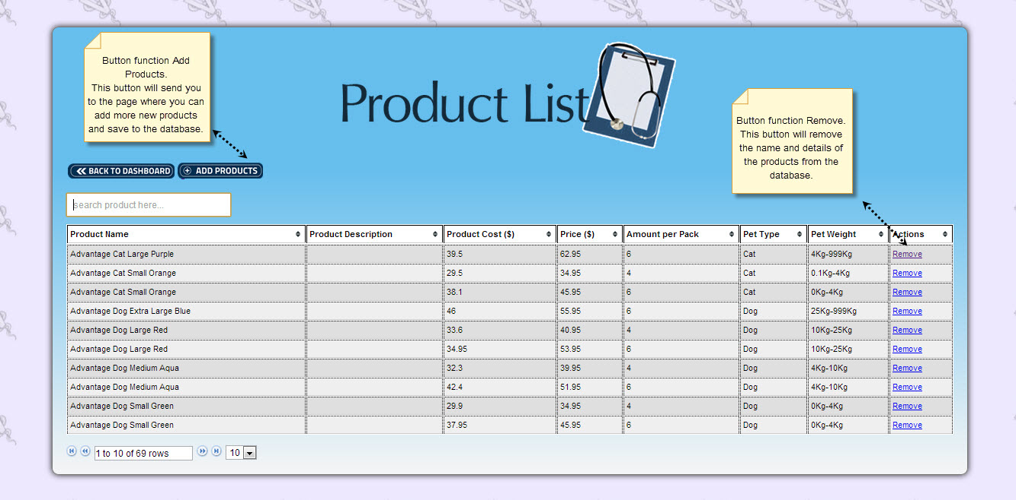

This page shows you the add button to add more products.

